**DAY 11 WE DONE THE MONGODB SETUP AND SOME OPERATIONS**

WE HAVE MONGODB COMPASS, MONGOSH COMMAND PROMPT:

THERE WE HAVE CREATE DATABASE .

INSIDE DATABASE THER HAVE COLLECTION.

**TASK 1:**

CREATE COMPUTER DATABASE INSIDE THERE HAVE TWO COLLECTION

1)Laptops  
 2)Details

3)laptops

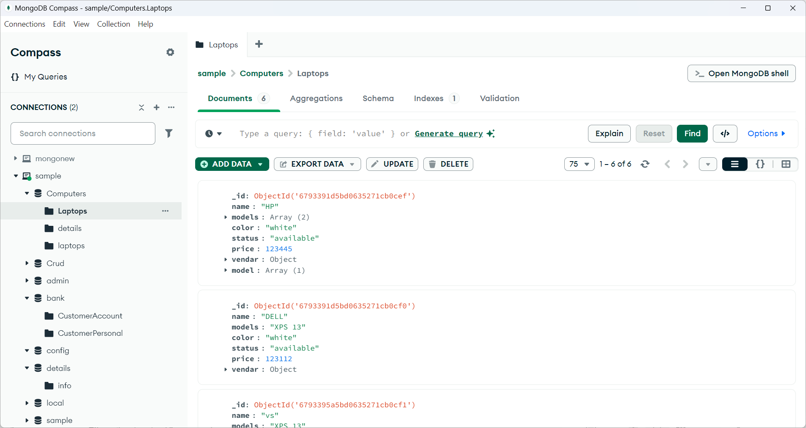

For laptop

**THERE ADDING OPERATIONS ARE DONE IN COMMANDS PORMPT USING SOME COMMANDS GIVEN IN WRRITEN NOTES.**

For example :

Insert one record in laptop

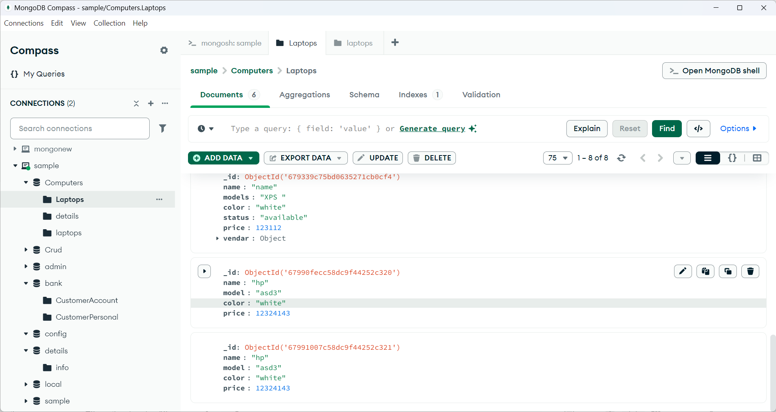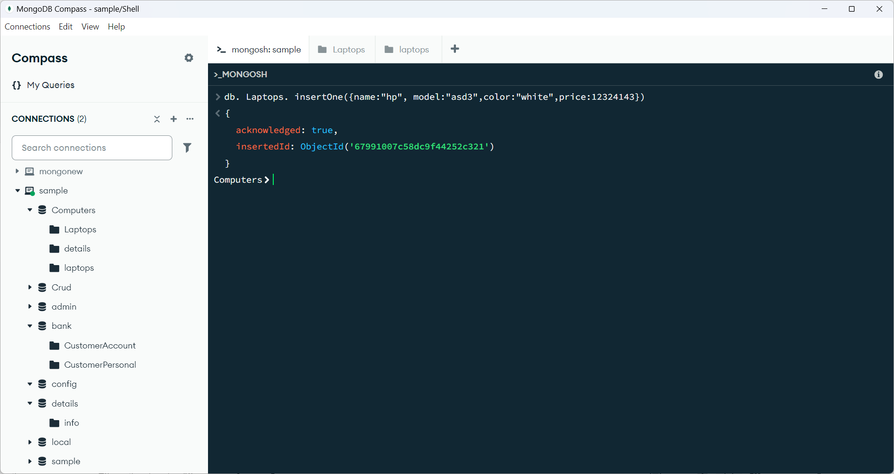COMMAND:

OUTPUT: